|  |
| --- |
| silver maple |
| *Acer saccharinum* L. |
| Plant Symbol = ACSA2 |

Contributed by: Kansas State University Forestry Research and USDA NRCS Plant Materials Center Manhattan, Kansas

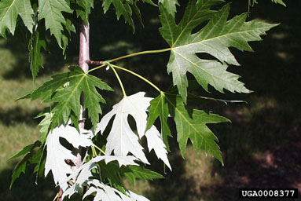

*Figure 1 Silver maple foliage.*

*Photo by Paul Wray, Iowa State University*

Alternate Names

soft maple, silverleaf maple, white maple, river maple, swamp maple, water maple

Uses

*Biofuels*: The species is one of only a few that has the growth rate for serious consideration for biofuel production. Though shrub willow and poplar hybrids are currently receiving greater attention, silver maple has been tested for this use in the Midwest.

*Forest Buffers*: Silver maple is ideal for riparian forest buffer installations due to its common presence in such sites. It should be planted because of its rapid growth and early maturity. Where silver maple is present in nearby stands, it should not be planted because it produces a prolific quantity of seed. In any planting, it is preferred over box elder.

*Ornamental:*  Its use should be limited as it becomes a liability with age.

*Wildlife*: Silver maple is not notable for its attractiveness to wildlife, but as a source of fast shading, large woody debris, and litter in streams the species has few rivals. It seems to be a preferred nesting species for Baltimore orioles.

Status

Please consult the PLANTS Web site and your State Department of Natural Resources for this plant’s current status (e.g. threatened or endangered species, state noxious status, and wetland indicator values).

Description and Adaptation

*Acer saccharinum* L., silver maple is one of the fastest growing deciduous trees of the eastern and mid-western forests. It can grow 3-7 feet per year. Silver maple shares many of its sites with red maple, but the two species are easily distinguished. Silver maple is typically a much larger tree with a much larger fruit (called a samara), but the two species are the only native maples with spring seed dispersal. The leaves of silver maple are often larger and more deeply fissured between lobes than those of red maple. Leaves are simple, opposite, deciduous, deeply lobed, narrow, and angled.

Silver maple is adapted wherever adequate moisture is assured, but grows best on well drained but moist river bottom soils. It cannot generally compete with other species in an upland environment (Gabriel 2009). The brittle nature of its wood limits the longevity of the species where high winds or heavy ice accumulations are common. As a pioneer species, silver maple is shade intolerant.

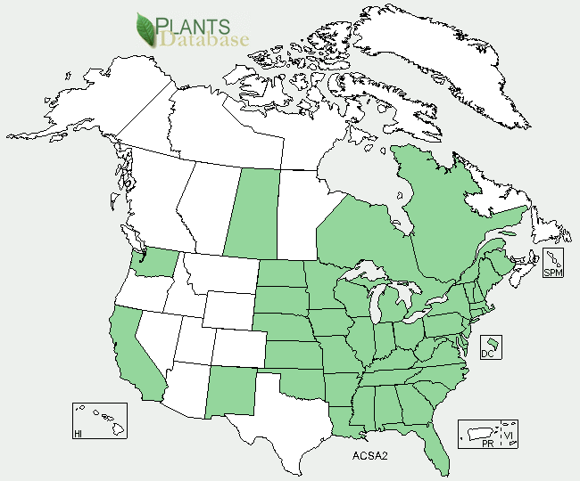

Silver maple distribution from USDA-NRCS-PLANTS Database.

Establishment

Silver maple is among the easiest of trees to establish from seed or transplants. Its rapid growth competes well with other plants, although grass and weed control will improve survival and allow for even better growth. The seed germinates rapidly, and streambanks underneath mature trees are often covered with seedlings shortly after seed dispersal in the late spring, especially along the waterline. The rapid growth means that seedlings are almost always out-planted as 1-0 stock.

Management

In buffer plantings the only management needed is grass and weed control and livestock exclusion. Silver maple is not usually damaged by deer browsing, and is not a preferred target of gypsy moth caterpillars.

On sites where natural regeneration produces too many saplings thinning should be carried out to allow other species to survive.

Pests and Potential Problems

Like other maples, silver maple is susceptible to a wide range of insect and disease problems. Gray mold spot is a foliage disease. A host of root and trunk rots attack silver maple. Because of its brittle wood properties, it is highly susceptible to ice damage.

Cultivars, Improved, and Selected Materials (and area of origin)

There are 58 cultivars names listed on the U.S. National Cultivated Plants list.

A few horticultural selections may exist in the market, but for conservation plantings seedlings from regional wild sources should be utilized.

Prepared By:

*Wayne A. Geyer, Professor*

*Forestry Division, Kansas State University*

*Manhattan, KS 66506*

*John Dickerson, retired*

*USDA NRCS, Plant Materials Specialist*

*John M. Row, Plant Materials Specialist*

*NRCS Plant Materials Center,*

*Manhattan, Kansas 66502*

**Citation**

Geyer, W. A., J. Dickerson, and J. M. Row. 2010. Plant Fact Sheet for Silver Maple (*Acer saccharinum* L.). USDA-Natural Resources Conservation Service, Manhattan Plant Materials Center, Manhattan, KS 66502.

Edited [29 Nov 10 jmr]

For more information about this and other plants, please contact your local NRCS field office or Conservation District, and visit the PLANTS Web site<<http://plants.usda.gov>> or the Plant Materials Program Web site <<http://Plant-Materials.nrcs.usda.gov>>

*The U.S. Department of Agriculture (USDA) prohibits discrimination in all its programs and activities on the basis of race, color, national origin, age, disability, and where applicable, sex, marital status, familial status, parental status, religion, sexual orientation, genetic information, political beliefs, reprisal, or because all or a part of an individual's income is derived from any public assistance program. (Not all prohibited bases apply to all programs.) Persons with disabilities who require alternative means for communication of program information (Braille, large print, audiotape, etc.) should contact USDA's TARGET Center at (202) 720-2600 (voice and TDD).*

*To file a complaint of discrimination write to USDA, Director, Office of Civil Rights, 1400 Independence Avenue, S.W., Washington, D.C. 20250-9410 or call (800) 795-3272 (voice) or (202) 720-6382 (TDD). USDA is an equal opportunity provider and employer."*

*Read about* [*Civil Rights at the Natural Resources Conservation Service*](http://www.nrcs.usda.gov/about/civilrights/)*.*